212: Digital Design I, week 13

Programmable Logic Devices (PLDs)
PLDs basically store binary information in a volatile/nonvolatile device. Data is specified by designer and physically inserted (Programmed) into the device.

Any Boolean function can be expressed in Sum of Products. SOP. In turn the SOP can be implemented in an AND-OR form.

ROM, PAL, PLA are different optimized implementations of a given circuit using the AND-OR planes.

Logic Gates
and
Programmable
switches
Inputs
(logic variables)
Outputs
( logic functions)
Programmable Logic Device as a black box

Input Buffers
and
Inverters
AND
Plane
OR
Plane
x1 x1 xn xn
P₁

P_{k}
Any combinational logic can be implemented with Sum of Product
which is AND-OR implementation.

f₁

f_{m}
x1 x2 xn-1 xn

Programming the AND_OR Plane

ROM: AND Fixed, OR Programmable

PAL: AND Programmable, OR fixed

PLA: AND Programmable, OR Programmable

FPGA: Programmable Logic Blocks, Programmable Interconnect

Example of programming the AND-OR planes

f1 (x1,x2,x3) = x1. x2 + x1 . x3’ + x1’ .x2’. x3
f2 (x1,x2,x3) = x1. x2 + x1’ .x2’. x3 + x3
Product

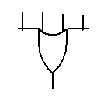
x1
x2
x3
P1
P2
P3
P4
f1
f2
Programmable Fuses
Connections
OR plane
SUM
AND plane

PLD basic cells:

The number of inputs and outputs are usually high. To avoid drawing all the inputs and outputs all the inputs to a gate is shown with one line only and the actual inputs are are shown as an intersection as shown below

AND
PLANE

PLD before programming
Programmable switches
OR
PLANE

So the previous example after programming will look like this

f1 (x1,x2,x3) = x1. x2 + x1 . x3’ + x1’ . x2’. x3
f2 (x1,x2,x3) = x1. x2 + x1’ . x2’. x3 + x1 x3


OR plane
P1
AND plane
x1
x2
x3
P2
P3
P4
f1
f2

Programmable Array Logic (PAL )

In this category of Programmable Logic devices the AND Plane is programmable and the OR Plane is fixed

Previous Example:

f1 (x1,x2,x3) = x1 x2 x3’ + x1’ .x2 x3
f2 (x1,x2,x3) = x1’. x2’ + x1 .x2 x3

OR plane (Fixed)
P1
AND plane (Programmable)
x1
x2
x3
P2
P3
P4
f1
f2

Programmable Logic Array (PLA)

Both AND-Plane and the OR-Plane are programmable.

Example:

Implement the following functions on a PLA
Size of the Device related to:
- cost;
- speed;
- power.

?

You should choose:
- 3 variable input
- 5 product terms -> 5 AND gates
- 4 outputs -> 4 OR gates

Personality Matrix
Product | Input |  |  | Output
Product | A | B | C | F0 | F1 | F2 | F3
 | 1 | 1 | - | 1 | - | 1 | -
 | - | 0 | 1 | - | - | - | 1
 | 1 | - | 0 | 1 | - | - | -
 | - | 0 | 0 | - | 1 | 1 | -
 | 1 | - | - | - | 1 | - | 1
 | For AND gate programming |  |  | For OR gate programming
1 – connection
0 – complementary
- – no connection

After programming
(* unused inputs of AND gates are connected to “1”;
** unused inputs of OR gates are connected to “0”)

When it is necessary to implement a Finite state machine, then we need a PAL or PLA that has extra circuitry such as a register and a Feedback path,
Then the following general circuitry can be added to some of the PLD devices.

f1
D Q
Select
Enable
Clock
To AND plane
Flip-flop

Example:
Implement the Finite state Machine given by the following equations on a suitable PAL. The PAL has SR flip Flops. These equations were derived for a particular state machine using SR-Flip Flops.
Excitation Vector:
S2 = P’ Q y₁, R2 = y₂, S1 = P’ Q’ , R1 = Q + P
Output :
Z= y2 y1’ P Q’ ,
P & Q – are inputs
y₂ & y₁ are the states
z is the output

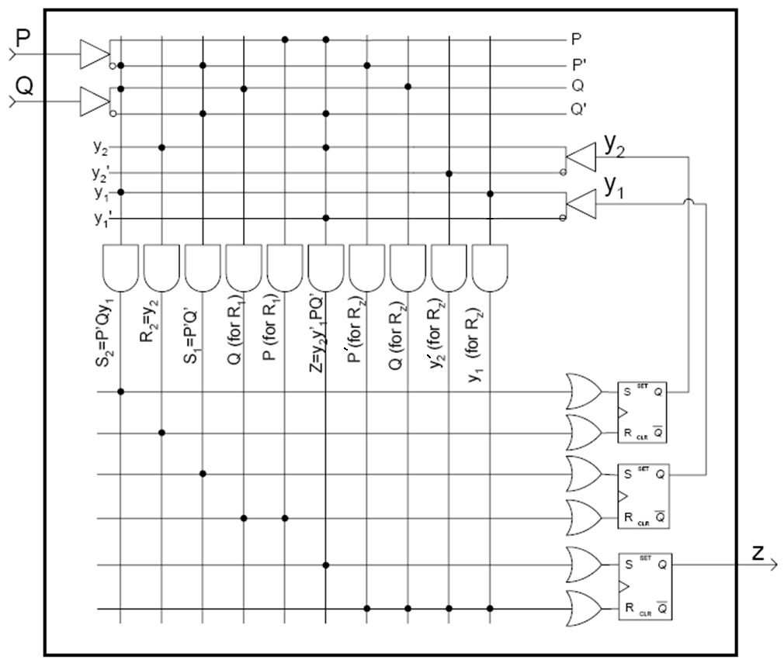

Programming the devices:

Programming the PAL
Logic expressions first must be minimized before programming the Pal.
PALs are programmed electrically using binary patterns (as JEDEC ASCII/hexadecimal files) and by using electronic programming device from a certain manufacturer such as Data I/O Corporation's Model 60A Logic Programmer.

User circuits are implemented in the programmable devices by configuring or programming these devices. Due to the large number of programmable switches in commercial chips; it is not feasible to specify manually the desired programming state for each switch. CAD systems are used to solve this problem.

Computer system that runs the CAD tools is connected to a programming unit.

After design of a circuit has been completed, CAD tool generates a file (programming file or fuse map) that specifies the state of each switch in PLD. PLD is then placed into the programming unit and the programming file is transferred from the computer system to the unit. Programming unit then programs each switch individually.

Most General of all PLDs is the FPGA or Field Programmable Gate Arrays, where, both cells of combinational logic and the routing can be programmed. Current FPGA’s are available in 10nm technology having millions of gates.

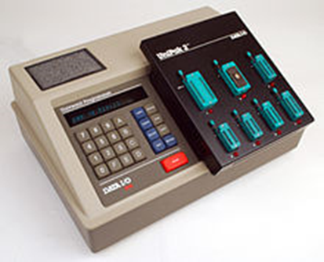Prices range from $500 $1000

So all you need is a Personal computer, PLD CAD tool, The programming device and its software and the kind of PLD that the device accepts.
Tutorial for PAL can be found at
http://courses.cs.washington.edu/courses/cse370/06au/tutorials/Tutorial_PAL.htm

Schematic of an FPGA is shown below.

Logic Block
I/O Cell

Example:
Design a PLA, PAL and ROM at a gate level to realize the following sum of product functions:
X(A,B,C) = A.B + A.B.C + A.B.C
Y(A,B,C) = A.B + A.B.C
Z(A,B,C) = A + B

A

B

C
ROM, generate the minterms
X = ∑m6, m7
Y = ∑m6, m7
Z = ∑m7, m6, m5, m4, m3, m2

• Fixed ♦ programmed

ROM Implementation
•
•
•
•
•
•
•
•
•
•
X

Y

Z
OR, generate the Functions

PAL Implementation

A

B

C

X

Y

Z
Product terms
ABC,AB,A,B

• Fixed ♦ programmed

♦
♦
♦
♦
♦
♦
♦
♦
♦
♦
♦
♦
♦
♦
♦

PLA Implementation
PLA

A

B

C
♦
♦
♦
♦
♦
♦
♦
♦
♦
♦
♦
♦
♦
♦
♦
♦
X

Y

Z

• Fixed ♦ programmed

Example 2
Design a function generator F=x² where x is a 3-bit unsigned binary number.
What size of ROM is required for this generator. Show your ROM and its content.
Answer:
For the 3-bit word there is 8 possibilities, we draw the Truth Table

x₂ x₁ x₀ | x | f₅ f₄ f₃ f₂ f₁ f₀ | F
0 0 0 | 0 | 0 0 0 0 0 0 | 0
0 0 1 | 1 | 0 0 0 0 0 1 | 1
0 1 0 | 2 | 0 0 0 1 0 0 | 4
0 1 1 | 3 | 0 0 1 0 0 1 | 9
1 0 0 | 4 | 0 1 0 0 0 0 | 16
1 0 1 | 5 | 0 1 1 0 0 1 | 25
11 0 | 6 | 1 0 0 1 0 0 | 36
111 | 7 | 1 1 0 0 0 1 | 49

Therefore the size of the ROM will be 8 words each of 6 bits.
It may be further minimized by noticing that f0=x0 and that f1 is=0. If we take these into account the size of the ROM is 8words of 4 bits each.

3 to 8
Decoder
Programming point
F= f5 f4 f3 f2 f1 f0
2⁵ 2⁴ 2³ 2² 2¹ 2⁰
f₅ f₄ f₃ f₂ f₁ f₀
0 0 0 0 0 0
0 0 0 0 0 1
0 0 0 1 0 0
0 0 1 0 0 1
0 1 0 0 0 0
0 1 1 0 0 1
1 0 0 1 0 0
1 1 0 0 01

